LAB 4

Toleubek Assiya 23B150271

TASK 1: Exploratory Probability Analysis
- Overall churn probability – P(Churn)
The overall churn probability is 26.5%, meaning that approximately one out of four customers left the company

- Conditional probabilities:
  - P(Churn | Contract = "Month-to-month")
Customers with month-to-month contracts have a churn probability of 42.7% (higher than overall churn rate)
  - P(Churn | tenure < 12 months)
Churn probability is 48.3%, indicating that new customers are at very high risk of churn
  - P(Churn | InternetService = "Fiber optic")
Customers using fiber optic internet have a churn probability of 41.9%, which is substantially above the baseline rate.
  - P(Churn | PaymentMethod = "Electronic check")
Customers paying via electronic check show a churn probability of 45.3%, suggesting this payment method is strongly associated with churn

- Joint / sequential probability:
  - For a customer with Month-to-month contract and Fiber optic internet, calculate P(Churn).
More than half of customers with a month-to-month contract and Fiber optic Internet leave.

  - Compare this with the overall churn probability and compute the lift.

This segment is 2 times more likely to churn than the average customer

- Feature comparison:
  - Which contract type has the lowest churn probability?
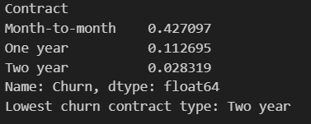
Customers with a two year contract exhibit the lowest churn probability, indicating that long-term contracts significantly reduce customer attrition.
  - Do senior citizens (SeniorCitizen = 1) have higher or lower churn probability than non-seniors?

Senior customers are substantially more likely to churn (0.417>0.236)
  - Is PaperlessBilling associated with higher churn? Quantify the difference.
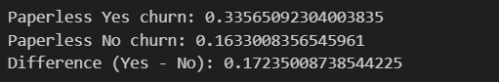
The difference of 0.172 percentage points suggests a strong association between paperless billing and churn.

- Visualization: Create a bar chart showing churn probabilities for the top 5 most predictive categorical features (choose based on the largest absolute difference from the overall churn rate).
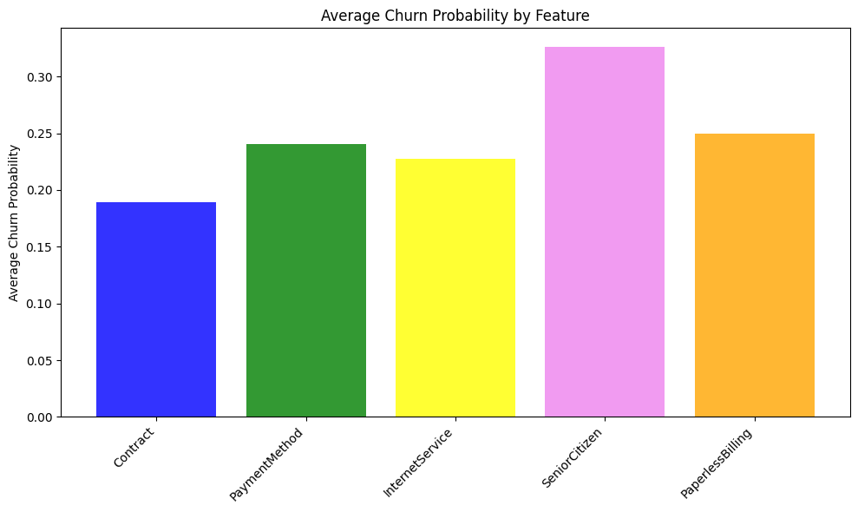
Main churn drivers are short contracts and certain payment methods. Further analysis by category would help prioritize retention strategies.

TASK 2: Naive Bayes Classifier from Scratch
Implement a Naive Bayes classifier to predict customer churn without using scikit-learn’s Naive Bayes modules. Follow these steps:
- Data preparation:
  - Convert TotalCharges to numeric; handle missing values appropriately.
  - Decide how to treat numerical features (tenure, MonthlyCharges, TotalCharges):
    - Option A: Discretize into bins (e.g., quartiles) and treat as categorical.
    - Option B: Estimate mean and variance per class and assume a normal distribution.
  - Split the data into training (80%) and test (20%) sets.
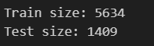

- Probability calculations:
  - Compute prior probabilities P(Churn) and P(No Churn) from the training set.

  - For categorical features, compute P(feature = value | class) for every value.
  - For numerical features (if using normal assumption), compute the mean and standard deviation of the feature for each class.
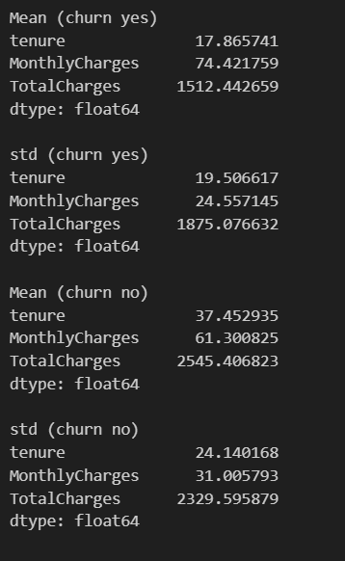
Customers who churned (Churn = 1) have:
lower tenure (17.9 vs 37.5),
higher MonthlyCharges (74.4 vs 61.3),
lower TotalCharges (1512 vs 2545)
This suggests that churn customers tend to leave earlier, pay higher monthly fees
- Prediction:
  - For each customer in the test set, calculate:
P(Churn | features) ∝ P(Churn) · ∏ P(feature_i | Churn)
P(NoChurn | features) ∝ P(NoChurn) · ∏ P(feature_i | NoChurn)
  - Normalize to obtain proper probabilities.
  - Predict Churn if P(Churn | features) > 0.5.
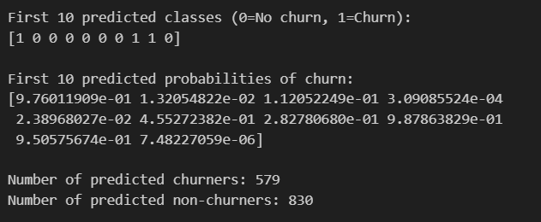
Out of 1409 test customers, 579 are predicted to churn and 830 to stay. The first 10 predictions show that the model assigns high probabilities to likely churners and low probabilities to non-churners, demonstrating that the model is working as expected

- Evaluation:
  - Compute accuracy, precision, recall, and F1-score.
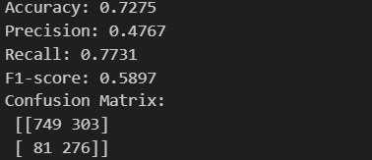
The model correctly predicts almost 3 out of 4 customers (accuracy=0.728)
Precision=0.477 of all customers predicted to churn, almost half actually churn.
The model successfully identifies most customers who actually churn(recall=0.773)
A balance between Precision and Recall = 0.589 (f1 score)

  - Display a confusion matrix.

The model is more likely to catch churn (recall is high), but precision is lower - there are many false positives.

  - Plot the ROC curve and calculate the AUC.
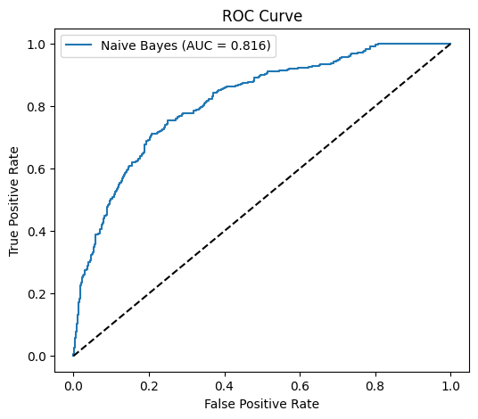
An AUC of 0.816 indicates good predictive performance, meaning the model correctly ranks high-risk customers with a high probability of churn.

  - Create a calibration plot (predicted probability vs. actual fraction of positives). Discuss whether your model is well calibrated.
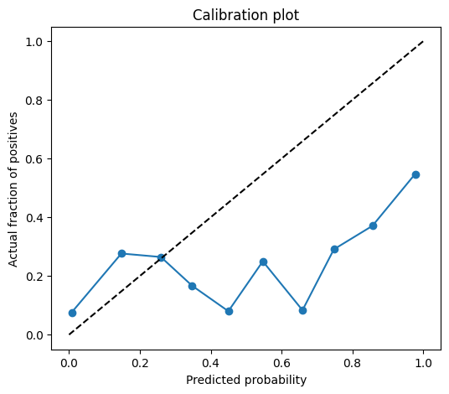
The calibration plot indicates that predicted probabilities are not perfectly calibrated, particularly in higher probability ranges. This means the model ranks customers well but slightly overestimates churn probabilities

- Comparison: Run the same evaluation using sklearn.naive_bayes.GaussianNB and/or CategoricalNB (depending on your feature encoding). Compare results and comment on any differences.
GaussianNB from sklearn slightly improves accuracy but shows the same patterns. Both models indicate high-risk features are Month-to-month contracts, Fiber optic internet, and Paperless billing.

TASK 3: Business Decision Analysis
Scenario:
- Average customer lifetime value (CLV) = $2,000.
- A retention campaign costs $300 per customer.
- The campaign has a 40% success rate (i.e., if a customer would have churned, the campaign prevents it with probability 0.4).
Answer the following questions, showing all calculations and reasoning:
- Expected value of targeting an individual:
  - What is the maximum amount you should spend to retain a customer whose churn probability is 0.8?
For a customer with an 80% chance of leaving, the maximum cost to retain is $640.
  - Calculate the expected profit (or loss) of targeting all customers with P(Churn) > 0.5. Use your Naive Bayes predictions (or a simple proxy if predictions are not yet available) to estimate churn probabilities.
The expected total profit from the retention campaign is $251,282. This shows that the campaign is highly profitable when focusing on high-risk customers identified by the Naive Bayes model.

- Risk segmentation matrix:
  - Define:
    - High Value: MonthlyCharges > $70
    - High Risk: P(Churn) > 0.6
  - Create a 2×2 matrix with quadrants:
(High Value / High Risk), (High Value / Low Risk), (Low Value / High Risk), (Low Value / Low Risk).
  - For each quadrant, report:
    - Number of customers
    - Expected churn loss without intervention (in dollars)
    - Expected net gain with the $300 retention campaign
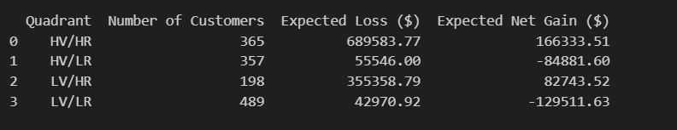
  - Which quadrant offers the highest ROI?
HV/HR quadrant offers the highest ROI

- Budget optimization:
  - You have a $50,000 retention budget.
  - Using your Naive Bayes churn probabilities, determine which customers to target to maximize expected total profit.
  - Hint: For each customer, compute Expected value = P(Churn) × CLV × 0.4 – 300. Sort customers by this value and select the top ones until the budget is exhausted.
  - Report:
    - Number of customers targeted
    - Total expected profit from the campaign
    - Percentage of the high-risk segment covered
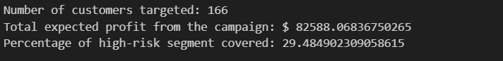
We selected 166 customers to target with the retention campaign within the $50,000 budget;
By targeting these customers, the expected total profit is $82,588, showing that careful selection maximizes ROI;
The campaign covers almost 30% of the high-risk customers (P(Churn) > 0.6), focusing on the most likely churners while staying within budget.

- Sensitivity analysis:
Re-evaluate your optimal strategy under three alternative scenarios:
  - Success rate drops to 20%.
  - Retention cost rises to $500.
  - Average CLV is actually $1,500 (instead of $2,000).
For each scenario, state whether you would still run the campaign and how your targeting would change.
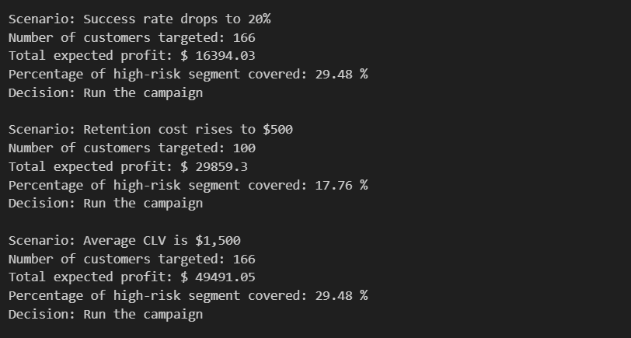
Access rate drops to 20% → profit $16,394, 29.5% coverage
Retention cost rises to $500 → profit $29,859, 17.8% coverage
CLV = $1,500 → profit $49,491, 29.5% coverage
The campaign is most effective when focusing on high-value, high-risk customers, and remains robust under different scenarios.

